Order Of Service

Singing: Psalm 72—CW page 93

Reading: Psalm 115

Opening Hymn: TLH 604

Reading: Romans 1:1-7

Request Hymn: CW Supplement 702

Reading: Matthew 13:24-30

Sermon Hymn: TLH 605

Sermon Text: Mark 13:32-37

Watch! Watch! Watch!

Prayer

The Apostles’ Creed, TLH page 12

Holy Communion

The Lord's Prayer

The Blessing

Closing Hymn: TLH 446

* * * * * * * * * * *

Bible Study: Lambs: Badger
Sheep: Proverbs 23:16-21

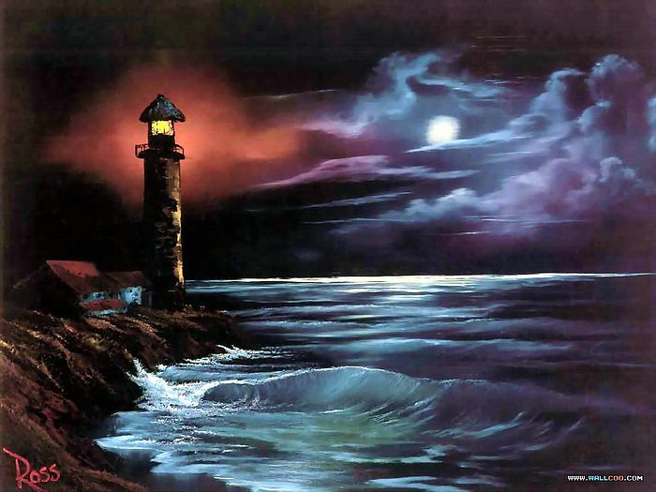

Guiding Light

Water
Of
Life

19 April 2020

W A T E R O F L I F E

Independent Christian Church—Conservative Lutheran Doctrine

Worship Service: 9:30 a.m. Bible Study: 10:45 a.m.

Larry Cooper, Pastor E-Mail address:
111 N. Ridge Road lcooper@wateroflife.cc
Coon Valley, WI 54623 Web Site:
www.wateroflife.cc

* * * * * * * * * * * * * * * * * * * * * * * * * * *

Sermon Text: Mark 13:32-37

Watch! Watch! Watch!

* * * * * * * * * * * * * * * * * * * * * * * * * * *

Mark 13:32 But of that day and that hour knoweth no man, no, not the angels which are in heaven, neither the Son, but the Father.
:33 Take ye heed, watch and pray: for ye know not when the time is.
:34 For the Son of man is as a man taking a far journey, who left his house, and gave authority to his servants, and to every man his work, and commanded the porter to watch.
:35 Watch ye therefore: for ye know not when the master of the house cometh, at even, or at midnight, or at the cockcrowing, or in the morning:
:36 Lest coming suddenly he find you sleepin:37 And what I say unto you I say unto all, Watch.

* * * * * * *

Luke 17:24-30

24 For as the lightning, that lighteneth out of the one part under heaven, shineth unto the other part under heaven; so shall also the Son of man be in his day.
25 But first must he suffer many things, and be rejected of this generation.
26 And as it was in the days of Noe, so shall it be also in the days of the Son of man.
27 They did eat, they drank, they married wives, they were given in marriage, until the day that Noe entered into the ark, and the flood came, and destroyed them all.
28 Likewise also as it was in the days of Lot; they did eat, they drank, they bought, they sold, they planted, they builded;
29 But the same day that Lot went out of Sodom it rained fire and brimstone from heaven, and destroyed them all.
30 Even thus shall it be in the day when the Son of man is revealed.

